Licencia | Imagen | Autor | Url
Dominio publico | 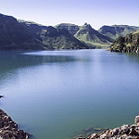 | Bonnie Moreland | https://www.flickr.com/photos/icetsarina/28069409258
CC BY | 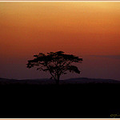 | Onofre Pimenta | https://www.flickr.com/photos/opimentas/4836093062/
CC BY-NC | 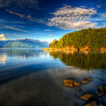 | Daniel Hoherd | https://www.flickr.com/photos/warzauwynn/2253563721
CC BY-ND | 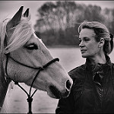 | Stefan Schmitz | https://www.flickr.com/photos/stefanschmitz/8647374873
CC BY-SA | 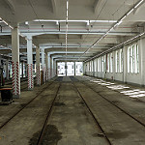 | H.KoPP | https://www.flickr.com/photos/kopp1963/42861742315/

